Scenario Based Learning
A company works with number of employees, all the works are dependents on the employees. Even if one of the employees resign the job immediately then assigned work will be not finished at the time, so delivery of the project to the clients will be delayed. Company planned to make solution for this, they want to know which employee may resign next. If they know previously, they can arrange alternative to avoid such problem. As an AI Engineer you must give Solution to this.
- A) How will you achieve this in AI?
- Collect past data of employee’s performance, engagement survey, Allocation and working hours, awards and appreciation, Promotion / Hike details, Employee / Manager relationship.
- B) Find out the 3 -Stage of Problem Identification
- Stage 1 – ML
- Stage 2 – Supervise
- Stage 3 - Classification
- C) Name the project
- Employee Attrition Prediction
- D) Create the dummy Dataset.
- 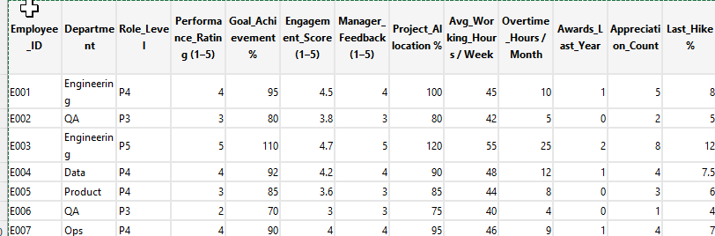

Data Type | Nature of Data | ML or NLP? | Why
Employee performance ratings | Structured (numeric, categorical) | ✅ Machine Learning | Used directly as features
Engagement survey scores | Structured (Likert scale, % scores) | ✅ Machine Learning | Numeric inputs
Allocation details (project, role, % allocation) | Structured | ✅ Machine Learning | Workforce analytics
Working hours / overtime | Structured (time-series, numeric) | ✅ Machine Learning | Pattern & trend analysis
Awards & appreciation (count, type) | Structured | ✅ Machine Learning | Recognition impact analysis
Hike / salary increment % | Structured | ✅ Machine Learning | Compensation modeling

